Deep Learning HW2

0851924 許朝鈞

1. Using Convolutional Neural Network for Image Recognition  
     
   Network architecture:

Inputs[28*28*1]  
 -> conv_1(patch: 5*5)[28*28*32]->relu->max_pool(2*2)[14*14*32]

-> conv_2(patch: 5*5)[14*14*64]->relu->max_pool(2*2)[7*7*64]

-> fc_1[1024]->relu->

-> fc_2[10]->softmax

* 1. 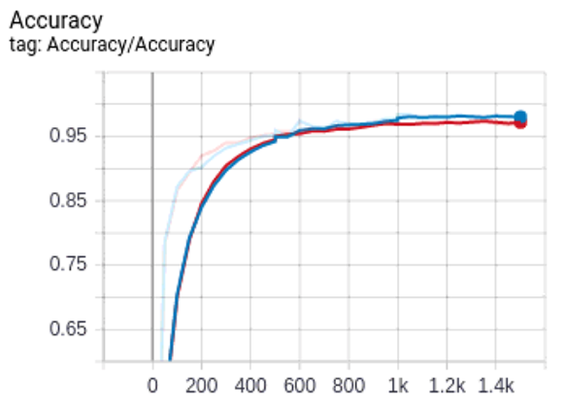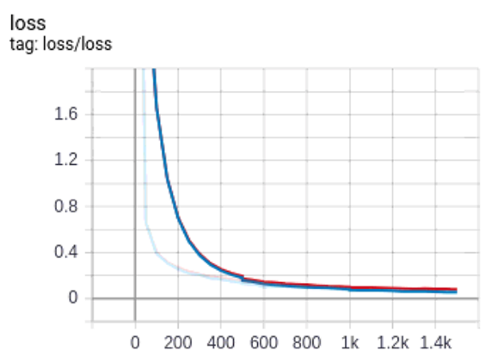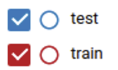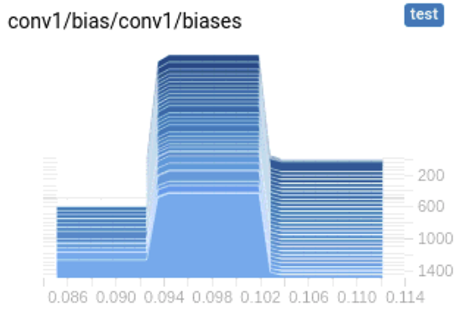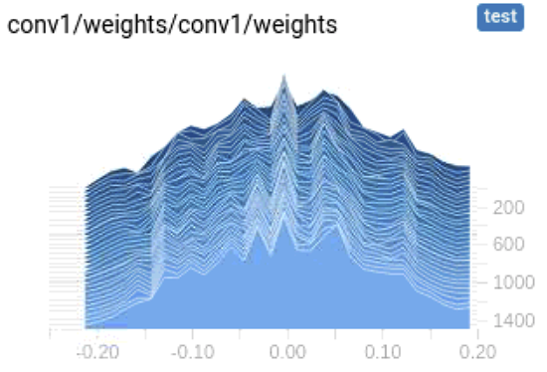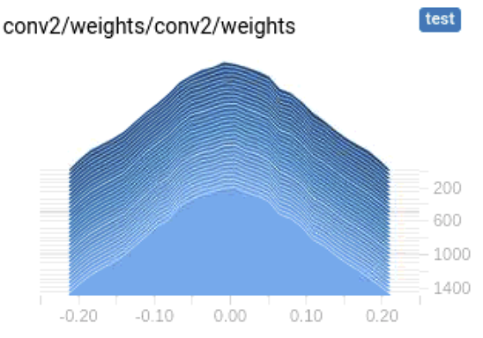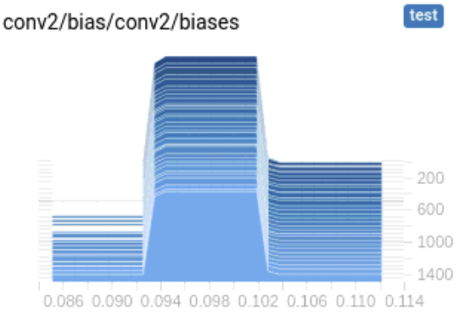  
       
       
       
       
       
       
       
       
       
       
       
       
       
       
       
       
       
       
       
     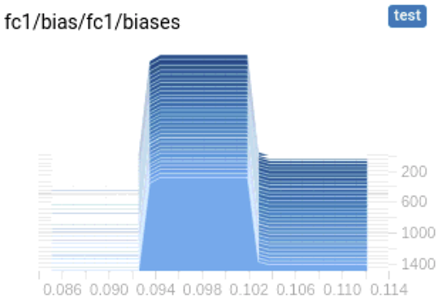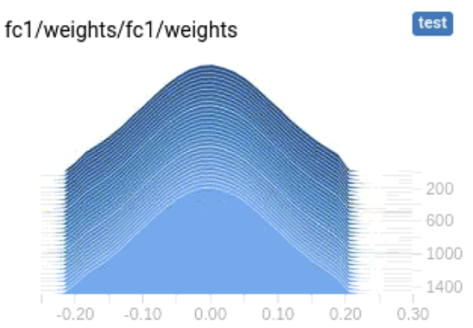  
       
       
     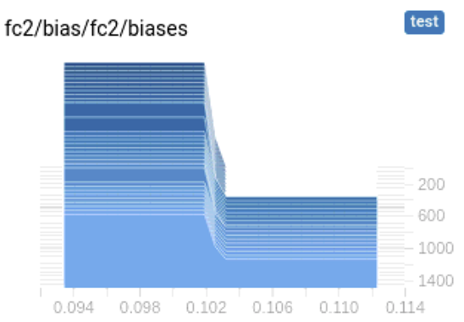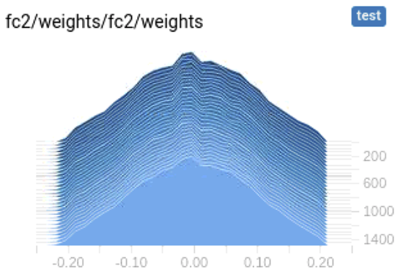  
       
       
       
       
       
       
       
       
       
     Fig. 1: Training accuracy, learning curve, and histograms of layers
  2. 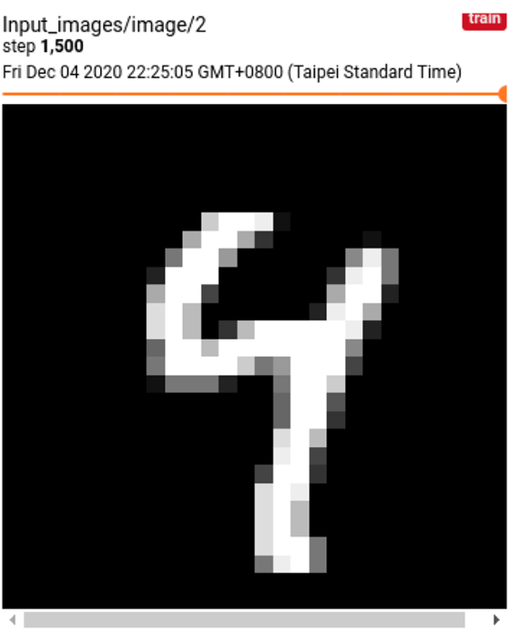  
       
       
       
       
       
       
       
       
       
       
       
     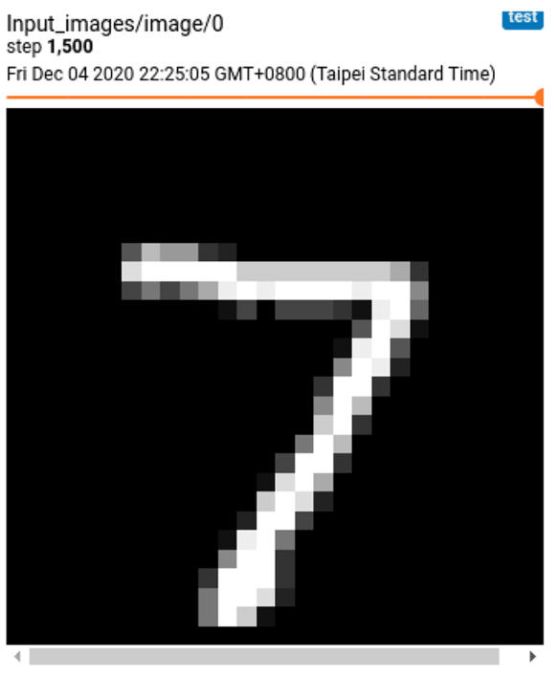 pred: 4, label: 9 pred: 7, label: 7  
     Fig. 2: Examples of correctly classified and miss-images
  3. 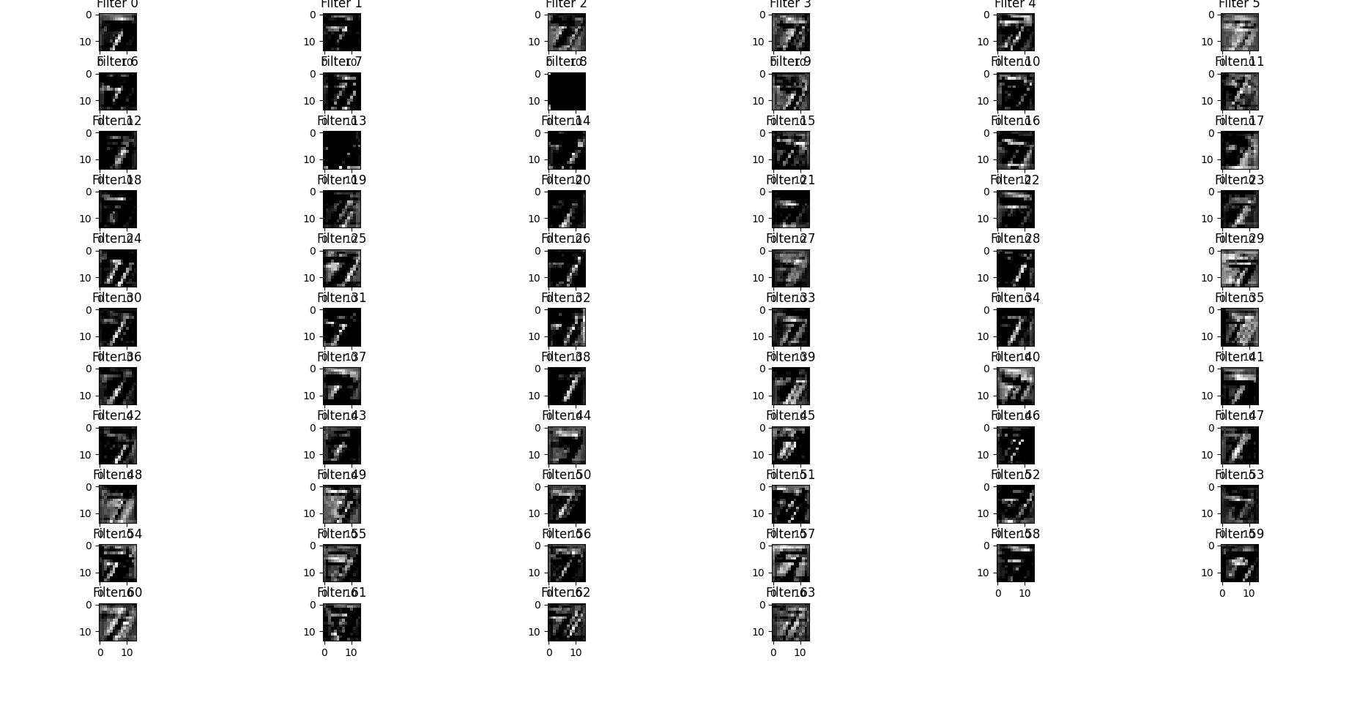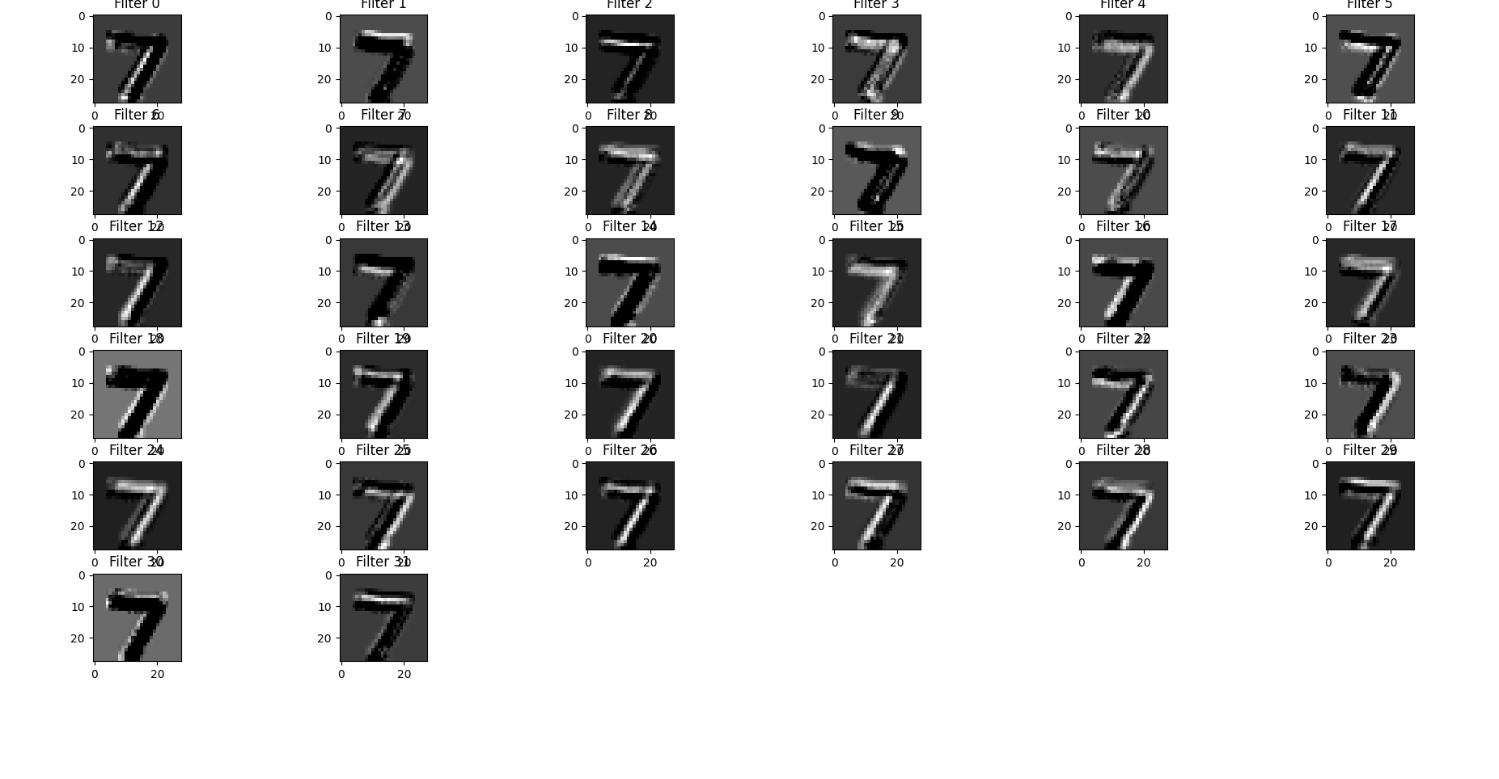  
     Fig. 3: Feature map of the first convolutional layer  
     Fig. 4: Feature map of the second convolutional layer

The feature map has been more uninterpretable as the convolutional layer getting deeper due to the extraction by the convolution filter, but it may made the network learn how to classify the number of the picture.

* 1. 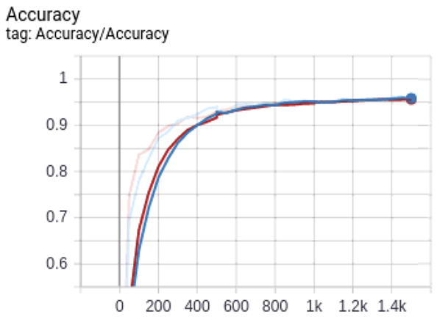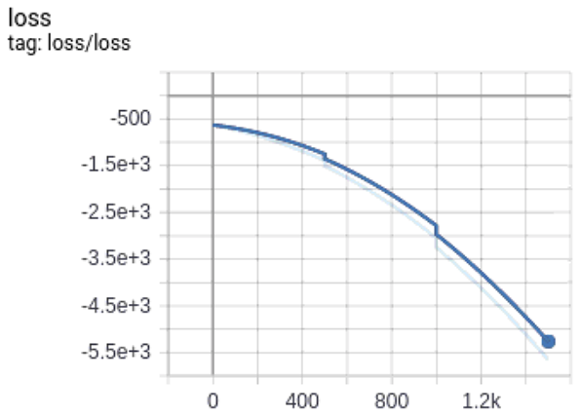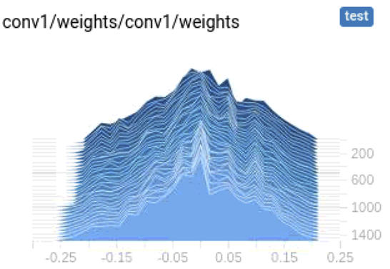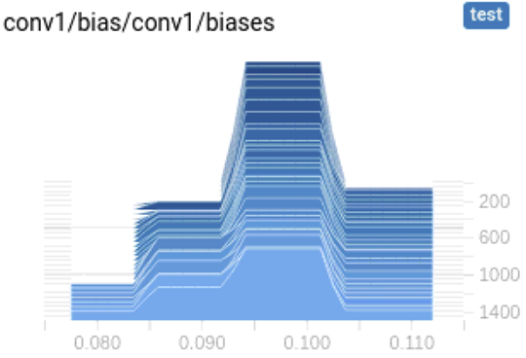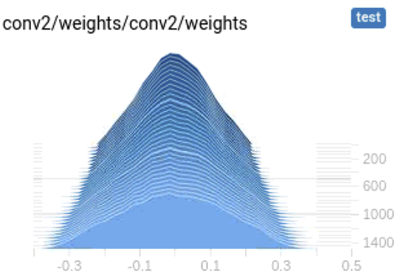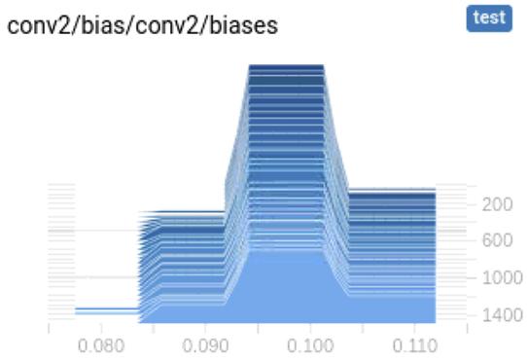  
       
     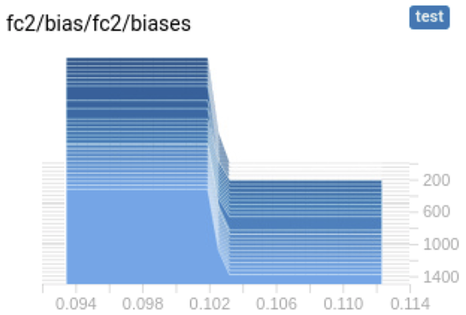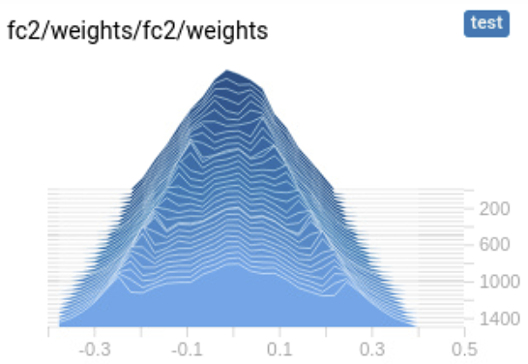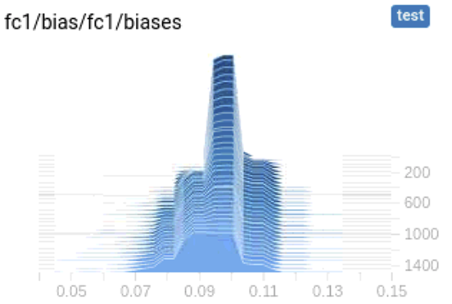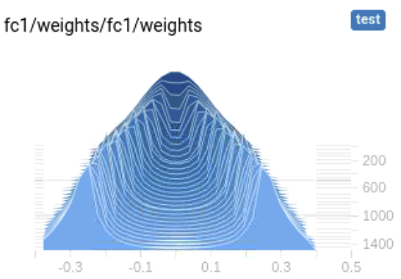Fig. 5: Training accuracy, learning curve, and histograms of layers

It made the whole weights including conv1, conv2, fc1, fc2 decrease, due to the penalty of the weights.

1. Preprocessing Before Using Convolutional Neural Network for Image Recognition
   1. 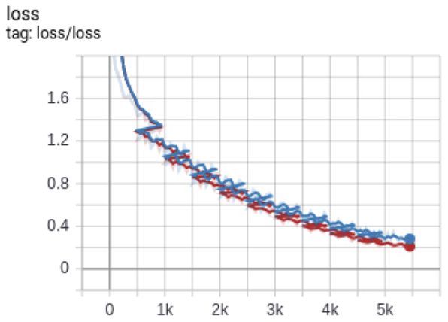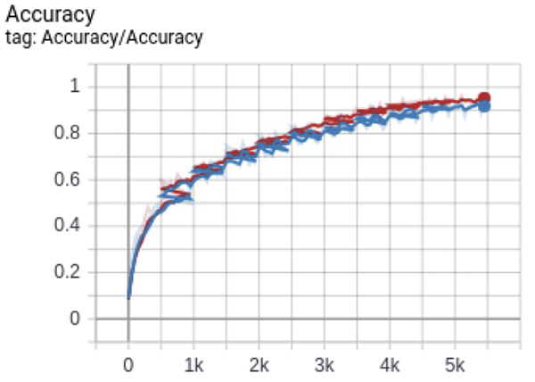  
        
      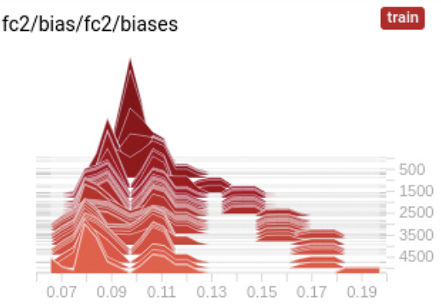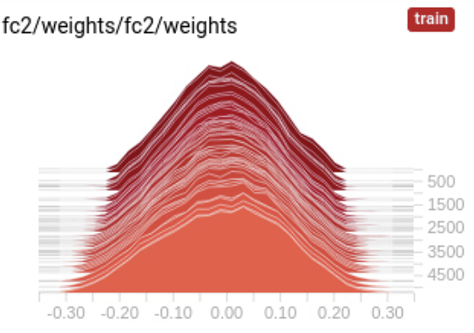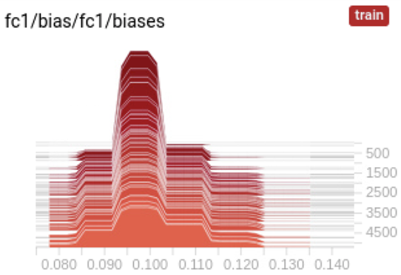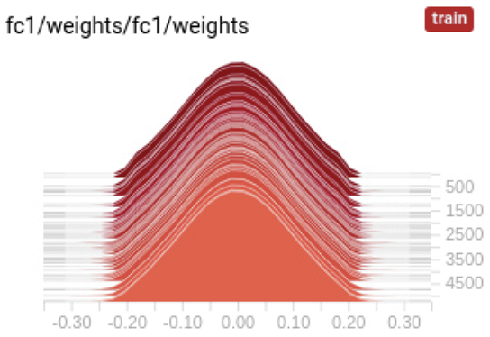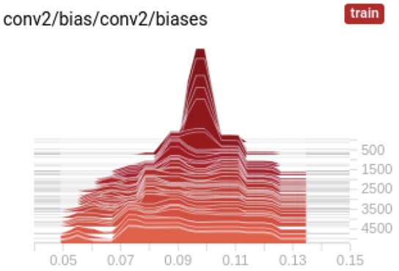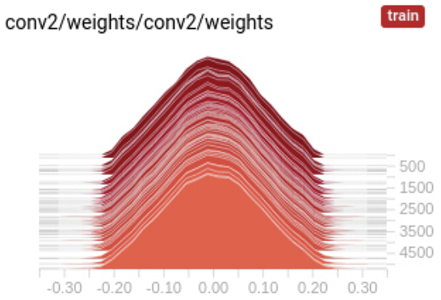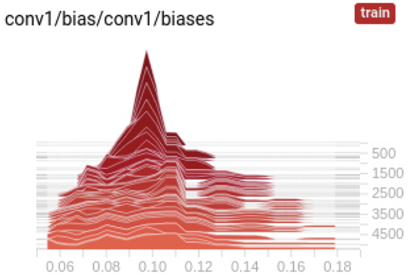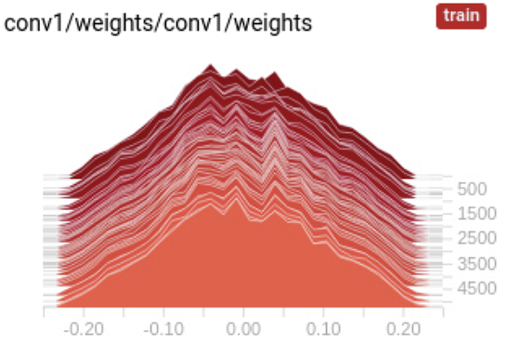Fig. 6: Training accuracy, learning curve, and histograms of layers
   2. 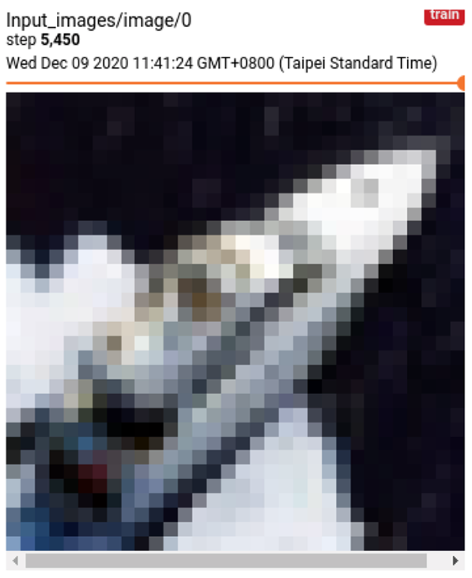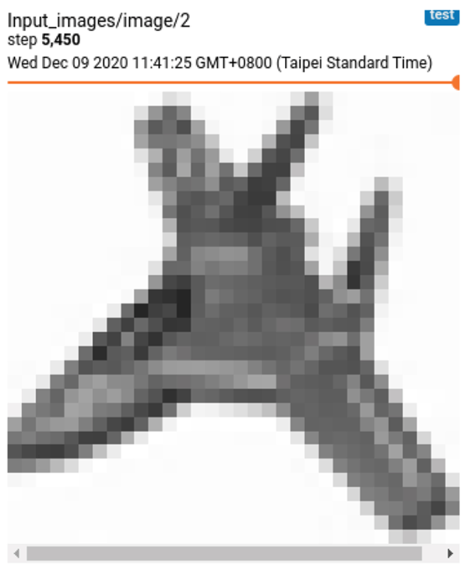  
        
        
        
        
        
        
        
        
        
        
        
       pred: deer, label: airplane pred: ship, label: ship  
      Fig. 7: Examples of correctly classified and miss-images
   3. The feature maps from different convolutional layers can’t be visualized, due to the color channel(3) is mixed after entering the first convolutional layer.
   4. 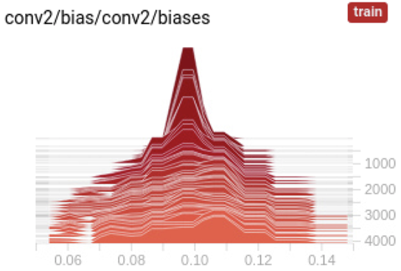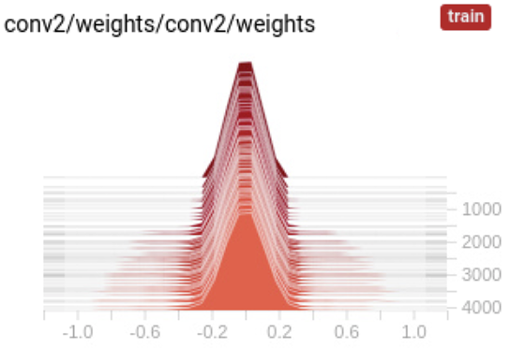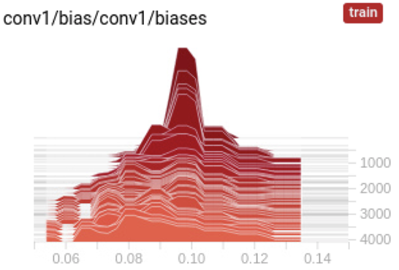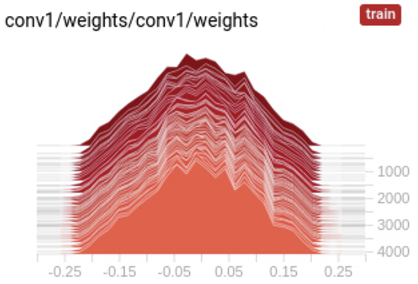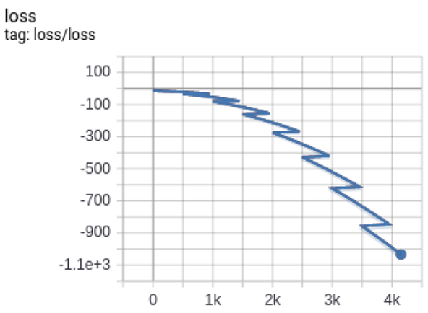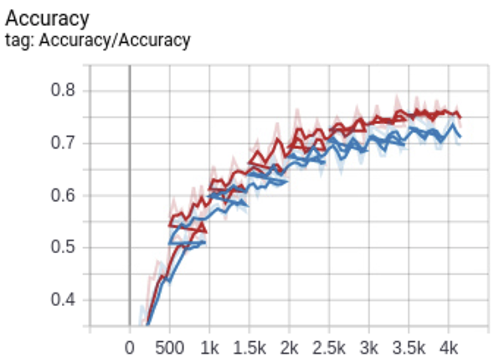  
        
        
        
        
        
      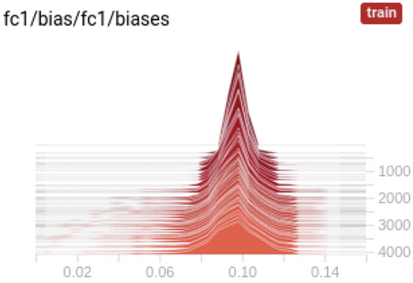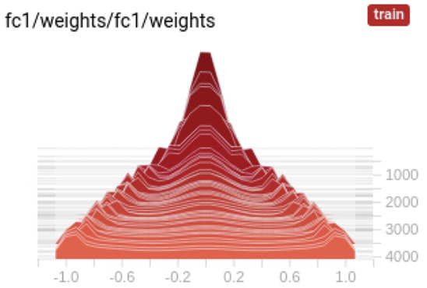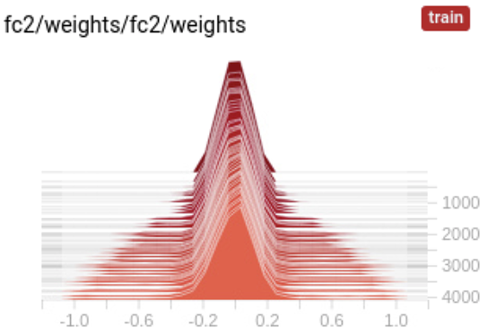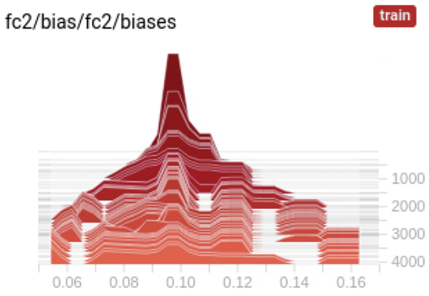Fig. 8: Training accuracy, learning curve, and histograms of layers  
       Same as the answer in first problem, it made the whole weights including conv1, conv2, fc1, fc2 decrease, due to the penalty of the weights.
   5. I’d changed the input tensor size into [N samples, 32, 32, 3]